### EXP NO: 2 VERIFICATION OF BOOLEAN LAWS AND THEOREMS

1. **OBJECTIVES:**

To verify Boolean laws such as Associative Law, Distributive Law, and Demorgans Theorem.

1. **TOOLS REQUIRED (MACHINES/EQUIPMENT/ACCESSORIES)**

|  |  |  |  |
| --- | --- | --- | --- |
| Sl.No. | COMPONENT | SPECIFICATION | QTY. |
| 1. | AND GATE | IC 7408 | 1 |
| 2. | NOT GATE | IC 7404 | 1 |
| 3. | OR GATE | IC 7432 | 1 |
| 4. | IC TRAINER KIT | - | 1 |

1. **PRE LAB WORK**
   1. **Theory / Definitions/ Formulas**

i) The associative law of addition is written as follows for three variables:

A + (B + C) = (A + B) + C

This law states that when ORing more than two variables, the result is the same regardless of the grouping of the variables.



Application of associative law of addition.

ii) The associative law of multiplication is written as follows for three variables:

A(BC) = (AB)C

This law states that it makes no difference in what order the variables are grouped when ANDing more than two variables.



Application of associative law of multiplication.

2.3.3 ***Distributive Law*:**

i) The distributive law is written for three variables as follows:

A(B + C) = AB + AC

This law states that ORing two or more variables and then ANDing the result with a single variable is equivalent to ANDing the single variable with each of the two or more variables and then ORing the products. The distributive law also expresses the process of factoring in which the common variable A is factored out of the product terms, for example,

AB + AC = A(B + C).



Application of distributive law.

2.3.4 **DeMorgan’s Theorem:**

i) The complement of a product of variables is equal to the sum of the complements of the variables,

***(***XY)’ = X’ + Y’

ii) The complement of a sum of variables is equal to the product of the complements of the variables***.***

**(**X + Y)’ = X’ Y’



* 1. **Design Procedure**

1. From the specifications of the circuit, determine the required number of inputs and outputs and assign a symbol to each.
2. Derive the truth table that defines the required relationship between inputs and outputs.
3. Obtain the simplified Boolean functions for each output as a function of the input variables using K-Map.
4. Draw the logic diagram and verify the correctness of the design.
   1. **Experimental Procedure**
5. Connections are given as per circuit diagram.
6. Logical inputs are given as per circuit diagram.
7. Observe the output and verify the truth table.
8. **IN LAB WORK**

**4.1 Safety Instructions**

1. Follow all written and verbal instructions carefully.
2. Perform only those experiments authorized by your teacher.  Carefully follow all instructions, both written and oral.  Unauthorized experiments are not allowed.
3. Be prepared for your work in the laboratory.  Read all procedures thoroughly before entering the laboratory.
4. Observe good housekeeping practices.  Work areas should be kept clean and tidy at all times.
5. Dress properly during a laboratory activity.
6. A lab coat or smock should be worn during laboratory experiments.
7. Don’t work or connect with equipment while power supply is **ON** state.

**4.2 Trouble shooting**

1. Check whether IC is working properly using the IC tester
2. Check for the loose connections in the circuit
3. Check for the short circuit in the connections.
4. Check for the correctness of the logic circuit.
5. **POST LAB WORK**

**COMMUTATIVE LAW:**

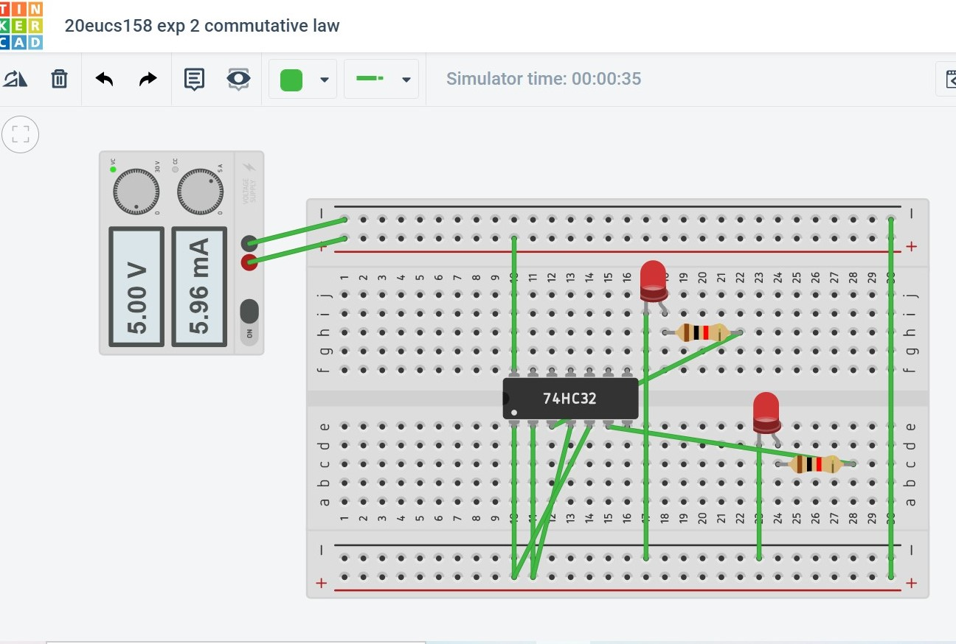

**ASSOCIATIVE LAW:**

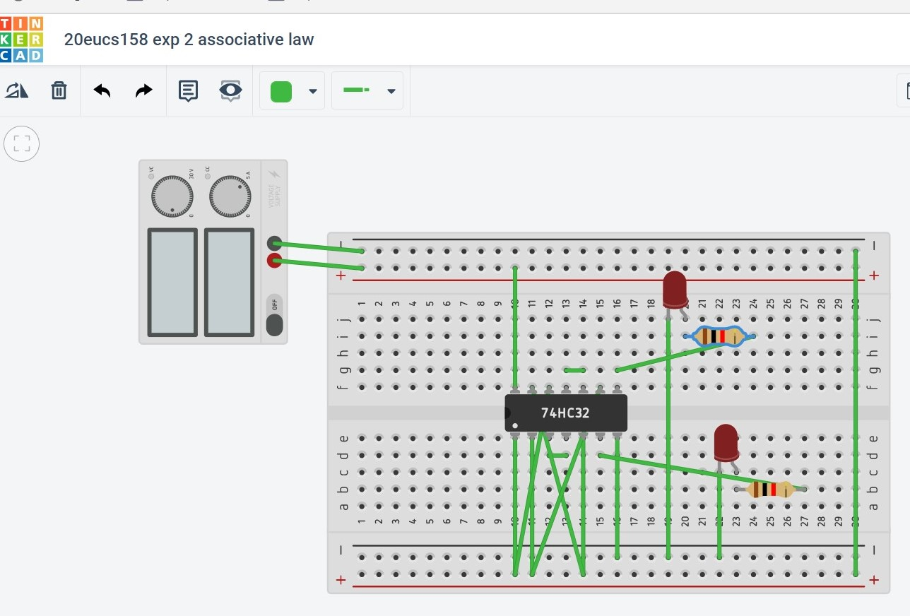

**DISTRIBUTIVE LAW:**

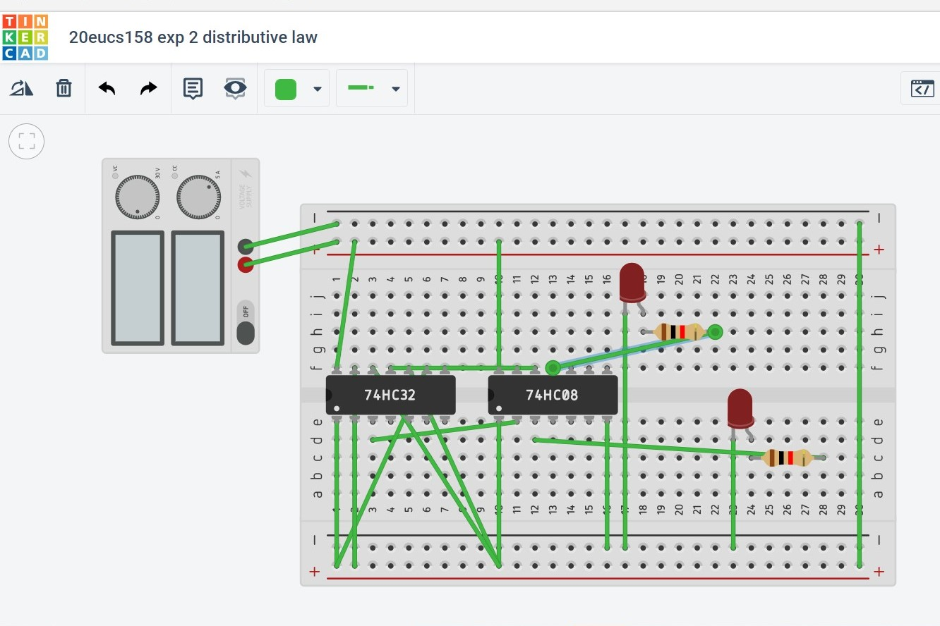

**DEMORGAN’S THEOROM:** 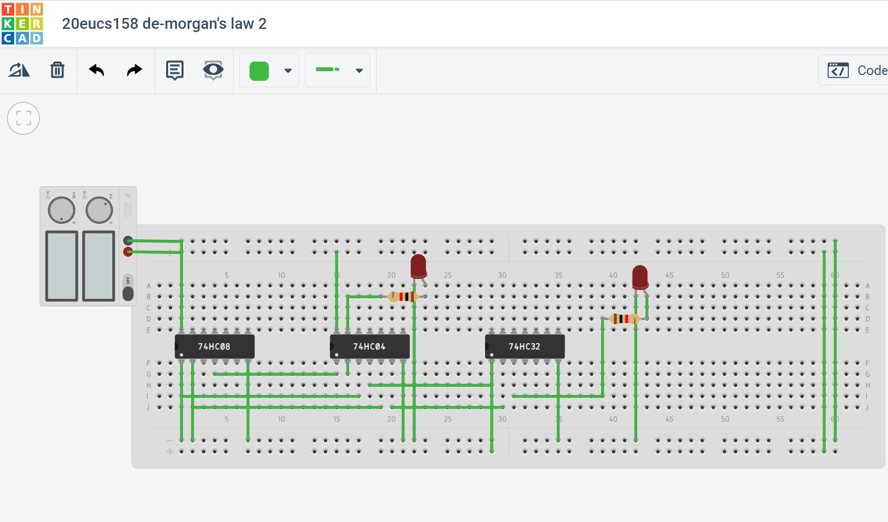

**5.1 Result analysis**

Thus the Boolean laws such as Commutative law, Associative Law, Distributive Law, Demorgan’s Theorem are verified with their truth tables.